
The Superior University Gold Campus, Lahore
Faculty of Computer Science & Information Technology
Department of Software Engineering
Task 5:AI (Lab)
Student Name | Muhammad Awais Ur Rehman
Roll No | BSSEM-S25-026
Section | BSSE-4A
Subject | AI (Lab)
Submitted To | Sir.Rasikh Ali

1. Problem Description
A game-playing agent has to choose a move while assuming that the opponent also plays the best way. If the agent looks at every leaf of the game tree, the work grows very fast, so it needs a way to skip branches that cannot change the final decision. In this lab I used the two small trees from the manual. I traced Minimax by hand, added a leaf counter to Minimax and Alpha-Beta.
2. Task 1: Hand Trace with Minimax
How I did Minimax by hand
Draw the tree with 3 levels of moves: depth 0 is MAX (root), depth 1 is MIN, depth 2 is MAX and depth 3 holds the 8 leaves.
Write the leaf utilities from left to right under the leaves.
Start from the bottom. For every depth 2 node (MAX), write the larger of its two children.
For every depth 1 node (MIN), write the smaller of its two children.
For the root (MAX), write the larger of the two depth 1 values. This is the Minimax value.
The move is the child of the root that gave this value. If both children are equal, I choose the left one.

Tree A
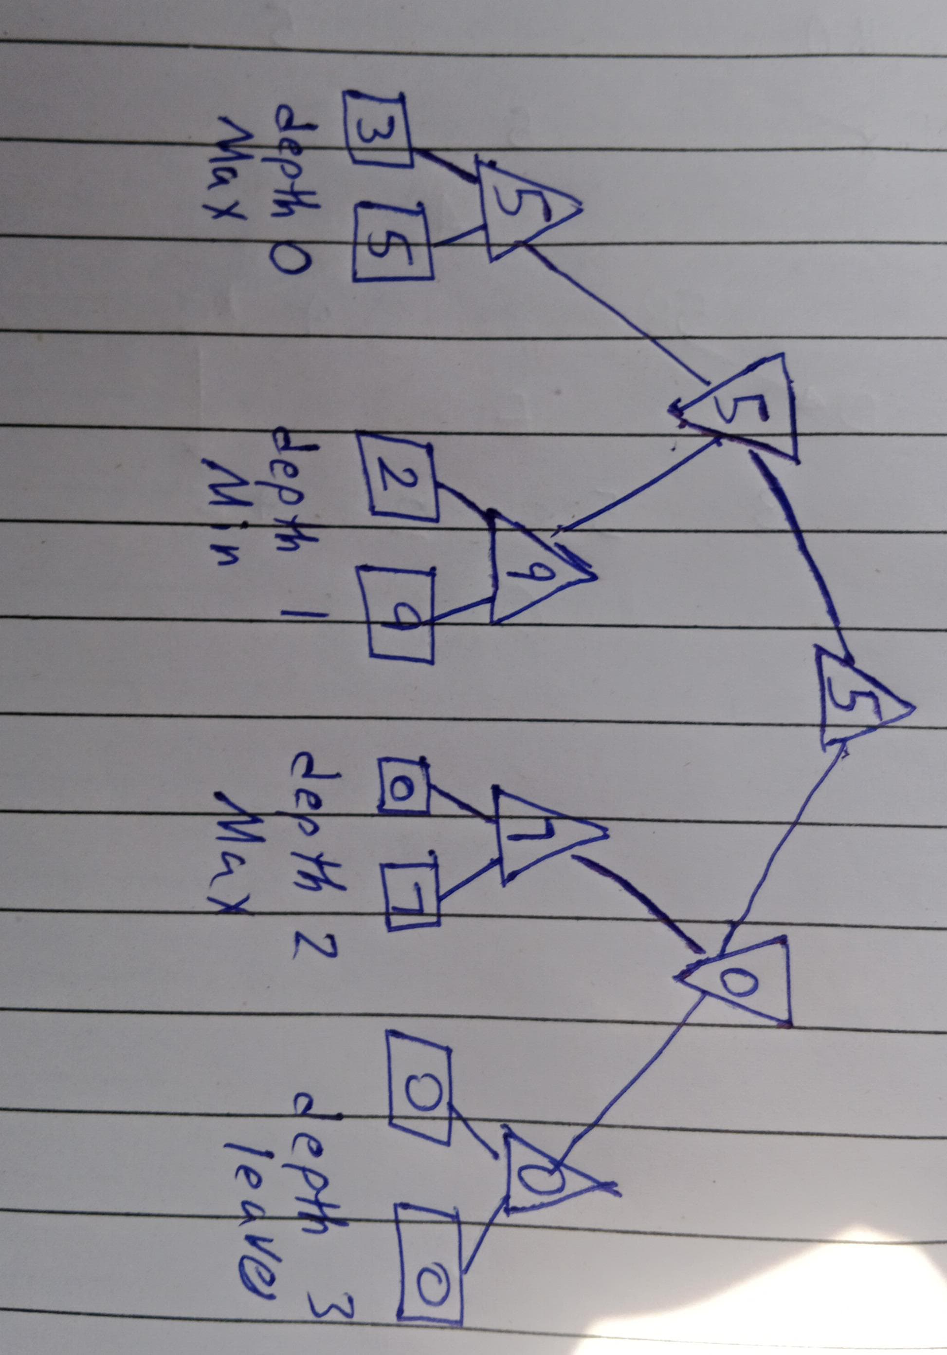

Depth | Node | Type | Calculation | Value
2 | 0 | MAX | max(3, 5) | 5
2 | 1 | MAX | max(2, 9) | 9
2 | 2 | MAX | max(0, 7) | 7
2 | 3 | MAX | max(0, 0) | 0
1 | 0 | MIN | min(5, 9) | 5
1 | 1 | MIN | min(7, 0) | 0
0 | 0 | MAX | max(5, 0) | 5 (root)

root value 5. The children of the root have values 5 (left) and 0 (right), so MAX chooses the left move.
Tree B
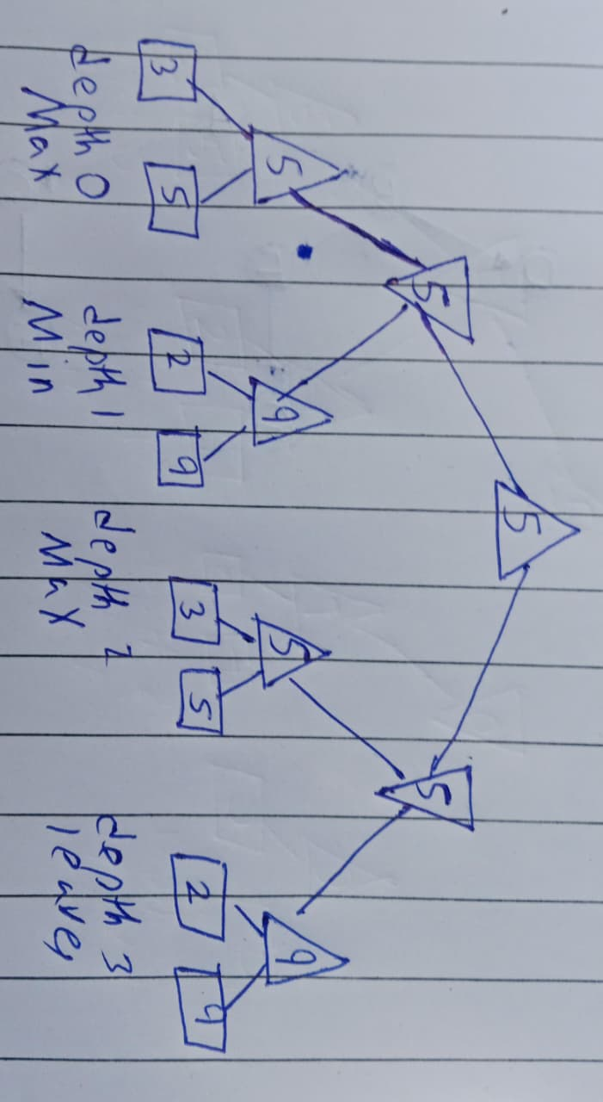
Depth | Node | Type | Calculation | Value
2 | 0 | MAX | max(3, 5) | 5
2 | 1 | MAX | max(2, 9) | 9
2 | 2 | MAX | max(3, 5) | 5
2 | 3 | MAX | max(2, 9) | 9
1 | 0 | MIN | min(5, 9) | 5
1 | 1 | MIN | min(5, 9) | 5
0 | 0 | MAX | max(5, 5) | 5 (root)

root value 5. Both children of the root have value 5, so there is a tie and In both trees MIN would reduce MAX's value from 9 to 5 on the left side, because MIN will not allow MAX to reach the 9.
3.Task 2: Leaf-Evaluation Counters
Results
Tree | Value | Minimax leaves | Alpha-Beta leaves | Leaves saved | Root move
Tree A (padded) | 5 | 8 | 8 | 0 | left
Tree B | 5 | 8 | 6 | 2 | left (tie 5 and 5)

Both algorithms give the same root value on both trees, and Alpha-Beta never evaluates more leaves than Minimax.

4.Task 3: Reordering Branches
All 128 orderings
Alpha-Beta leaves | Tree A orderings | Tree B orderings | Minimax leaves
5 | 8 | 16 | 8
6 | 32 | 48 | 8
7 | 40 | 16 | 8
8 | 48 | 48 | 8

Why ordering matters
Best order: 3, 5, 9, 2, 0, 0, 0, 7. On the left, MAX (9, 2) sees 9 first. Alpha = 9 is more than beta = 5, so leaf 2 is skipped. On the right, first MAX (0, 0) gives beta = 0, which is less than alpha = 5, so full (0, 7) is skipped. Total = 8 - 1 - 2 = 5 leaves.In worst order, MAX sees small child first and MIN sees big child first, so bounds are not tight and cut-off comes late.Value stays same because pruning only cuts the branch which the opponent will never allow.
5.Comparison of Minimax and Alpha-Beta
Case | Value | Minimax leaves | Alpha-Beta leaves | Saved
Tree A, original order | 5 | 8 | 8 | 0
Tree B, original order | 5 | 8 | 6 | 2
Tree B, best order | 5 | 8 | 5 | 3
Tree A, best order | 5 | 8 | 5 | 3

6. Testing, Edge Cases
Edge-case tests
Test | Input | Observed result
Single leaf | [7], depth 0 | Both return 7 and read 1 leaf
Two leaves | [3, 8] | Both return 8 and read 2 leaves
All leaves equal | [4, 4, 4, 4, 4, 4, 4, 4] | Both return 4. Minimax reads 8 leaves, Alpha-Beta reads 5, because equal values cause a cut (alpha >= beta).
Negative utilities | [-3, -5, -2, -9, -3, -5, -2, -9] | Both return -3. Alpha-Beta reads 5 leaves, Minimax 8.
Well-ordered tree | [3, 5, 9, 2, 3, 5, 2, 9] | Both return 5. Alpha-Beta reads 5 leaves.
Tie at the root | Tree B | Both children have value 5, the left move is chosen by my tie rule.

7.Limitations
- The trees are tiny (8 leaves), so the saving of Alpha-Beta is small and the numbers cannot show how it works on real games.
- The leaf utilities are given. I did not use a real game or an evaluation function.
- The code only handles complete binary trees with a fixed depth.
- All results use the counting rule that one leaf read is one evaluation. Another measure, such as time, could give different comparisons.

